**Project document**

**Project name: INTERNSHIP ALPPLICATION MANAGEMENT SYSTEM**

**Introduction**

Nowadays, finding internship or summer job to enhance competitiveness before their graduation has become an increasing tendency. For university students, doing internship is a way to have a greater chance to find the career in the future, but for elementary school and high school students, internship is the way to understand the different divisions of social labor so that the student can find their own interest among different areas. That is they will establish their goal of future and not completely be in dark when choosing s a major after graduation. For university students, it will not be easy to find a job via social recruitment, because a large number of companies will require working experience before a candidate apply for the job student will face same obstacles if they lack of real would experience.

The student in many universities needs to attain industrial attachments at the end of their studies where their universities request them to find the company or organizations help them in these internships in other to attain the working experience.

In the process of searching where they make the internship take a long time for the student in way of transport going to the company/organization to bring the document needed by the company before allow anyone to make internship in the organization, the introduced internship application management system is the system come for helping the student to make application in the organization easily where the students must send their request for internship on organization with full requirement via the system and make the response via emails if the applicant must be allowed or the request is rejected.

This system is used by the students need to make request for internship with fill their personal information and education information in other to express their proof of education background and the receptionist of the organization must be accept the request from the students and assign the request with providing the response to the clients/students.

The purpose of the internship application management system is to help the student to request the internship on the organization and make the response without the more cost of transport and saving their time. Because the student must upload the required document for internship and make the response about their request via the internship application management system.

**Requirement**

**Functional requirement**

There are requirement needed by the all users for the system where the system request the users to enter the same credential in other to assign the responsibilities of the user came to use the system.

When the users sign in the system after entering in the system, the system must assign their responsibilities based on their roles in the system like the following roles for each user of the system.

**Students**

The students must requested by the system to enter the personal information like: First name, last name, age, email ,phone numbers and the education information like university, college, department and the kind of internship request in the organization

**Receptionist of organization**

All request from the students must be seen by the receptionist of the organization and the receptionist must be check for the request have full information needed and must be sent to the department have the responsibilities to provide that kind of internship.

**Head of department**

The all request for internship requested by students must be sent in their related department and the head of the department must to accept or reject the request of internship based on the reasons that are available in the department.

**Human resources**

The applicants that are accepted to start internship in the department their request is sent into human resources department to confirm the accepted starting for internship in the organization.

**Authentication**

Each user must be entering in the system after providing login credential: where the system put the user on their dashboard based on the role of the user in the system then logout.

**Nonfunctional requirement**

This system of internship application management system contains the form of registration where the student requested to enter their information and upload the recommendation letter from the department.

Web server is another requirement for the system used to serve the request from the and the Mysql database used to keep information from the client and keep the information of student when the student make any request.

All user must reach to the home page means that the home page is the page viewed by everyone on the system and new user of the system must have button to make a registration and the existing users have the login form used to came back into the system.

After login for users the system redirect the user to the corresponding page based on the role of users in the system.

**Design**

This project, internship application management system, implements web system to provide an environment for student and organization to successfully complete the internship application. thus the component needed to implement internship application management system are database server, a web server, graphic user interface component and database interface application programming interface (API) to programmatically access to the database.

**Architecture design**

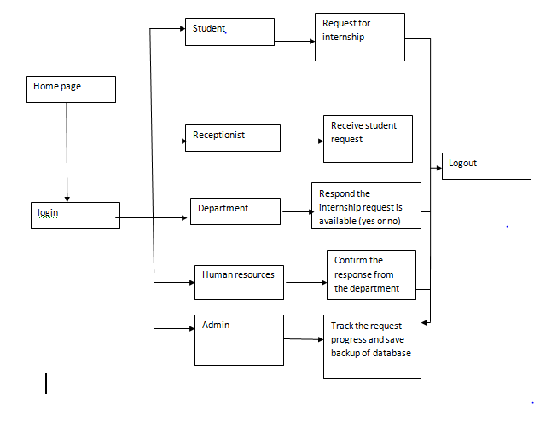

**Database design**

**Data analysis**

The data for designing and implementing the schema of the database depend on the properties of the pages and users.

The page data needed by the internship application management system are title, header, body and several tabs to move around the web pages. The user data needed by the system are the user social security or student id, username, password, first name, last name and email address. The role of user is automatically determined by the system at the time of login authentication and the user is automatically redirected to the appropriate page. All the user data will be checked on the server side when the user is created.

All information entered by the user will be checked and appropriate error message will be checked flagged include password mismatch and missing required fields. A unique number identifies every record stored in the database and that serves as a parameter to check integrity constraints and maintain true data in the database.

**Database schema conceptual model entity relationship diagram**

In designing the schema for the internship application management system database, two distinct parts have been identified. The first includes entities having relationship between them. The second include a description of the entities and their attributes.

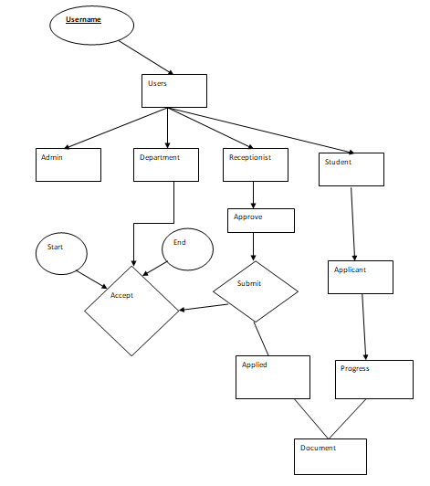

**Database schema logical model-relational schema**

The conceptual model entity relational diagram maps into the following table design. In the following tables, fields with key indicate the primary key.

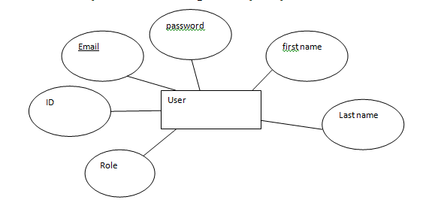

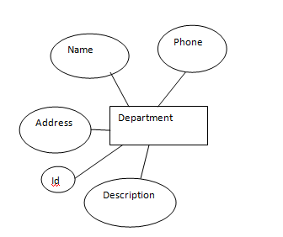

**Data type and details**

The logical model establishes the following detailed design in mysql database. The following table describes data type, length, primary key, null or non-null keys, and extra information in database is encrypted and it is shown in the web page as some special character repeated as many times as the length of the actual password.

**Structure of table users**

|  |  |  |  |  |  |
| --- | --- | --- | --- | --- | --- |
| **Field** | **Type** | **Null** | **Key** | **Default** | **Extra** |
| id | Int |  |  |  |  |
| First name | Varchar(40) | **no** |  |  |  |
| Middle name | Varchar(40) |  |  |  |  |
| Last name | Varchar(40) | **no** |  |  |  |
| Email | Varchar(40) | **no** | **Pri** |  |  |
| Password | Varchar(40) |  |  |  |  |
| Role_id | Int(3) |  |  |  |  |
| Created_time | Timestamp |  |  |  |  |
| Updated_tim | Timestamp |  |  |  |  |

**Structure of table student**

|  |  |  |  |  |  |
| --- | --- | --- | --- | --- | --- |
| **Field** | **Type** | **Null** | **Key** | **Default** | **Extra** |
| id | Int | **no** | **pri** |  |  |
| department | Varchar(40) | **no** |  |  |  |
| phone | Varchar(40) |  |  |  |  |
| Start_date | Varchar(40) | **no** |  |  |  |
| End_date | Varchar(40) | **no** |  |  |  |
| Company | Varchar(40) | **no** |  |  |  |
| Supervisor | Varchar(30) | **no** |  |  |  |
| Created_time | Timestamp |  |  |  |  |
| Upudated_at | Timestamp |  |  |  |  |

**Structure of table department**

|  |  |  |  |  |  |
| --- | --- | --- | --- | --- | --- |
| **Field** | **Type** | **Null** | **Key** | **Default** | **Extra** |
| Name | Varchar(60) |  |  |  |  |
| Address | Varchar(40) | **no** |  |  |  |
| Phone | Varchar(40) |  |  |  |  |
| Description | Varchar(90) | **no** |  |  |  |
| Created_at | Timestamp |  |  |  |  |
| Updated_at | Timestamp |  |  |  |  |

**Structure of table document**

|  |  |  |  |  |  |
| --- | --- | --- | --- | --- | --- |
| **Field** | **Type** | **Null** | **Key** | **Default** | **Extra** |
| id | Int(10) |  |  |  |  |
| Name | Varchar(40) | **no** |  |  |  |
| Created _at | Timestamp |  |  |  |  |
| Updated_at | Timestamp |  |  |  |  |

**Use case diagram**

Internship application management system is designed to perform several different function for different users

